PART A
--1
ALTER TABLE CUSTOMER
ADD CreditCardNumber NUMBER(12);
--2
ALTER TABLE RentalAgreement
MODIFY AgreementDate DEFAULT CURRENT_DATE;
--3
ALTER TABLE Customer
RENAME TO Client;
--4
ALTER TABLE Client
RENAME COLUMN PCode TO PostalCode;
--5
PURGE Recyclebin;
--6
CREATE INDEX idxFLName
ON Client(FName, LName)
ONLINE;
--7
EXEC DBMS_STATS.GATHER_TABLE_STATS(ownname=>'T218', tabname=>'Client', cascade=>TRUE);
--8
CREATE UNIQUE INDEX idxCreditCardNumber
ON Client(CreditCardNumber)
COMPUTE STATISTICS;
PART B
--9
CREATE SEQUENCE RA_Sequence
INCREMENT BY 3
START WITH 1000
MINVALUE 5
MAXVALUE 9999
CACHE 5
CYCLE;
--10
INSERT INTO RentalAgreement (AgreementID,CustID,AgreementDate,MovieCount,DurationID)
VALUES (RA_Sequence.NEXTVAL,23,CURRENT_DATE,1,1);
--11
INSERT INTO MovieRented (MovieID, AgreementID,RentalAmount,PercentReductionApplied)
VALUES (6, RA_Sequence.CURRVAL,3.76,0)
--12
CREATE PUBLIC SYNONYM T218_Movie
FOR Movie;
GRANT SELECT, UPDATE, INSERT ON Movie TO BHOTHI,MPOITRAS;
--13
EXEC BuildTables;
ANALYZE INDEX SamplePK
VALIDATE STRUCTURE;
PART C
--14
SELECT Name, Height, Blocks, BR_Blks, BR_Rows, LF_Blks, LF_Rows
FROM Index_Stats;

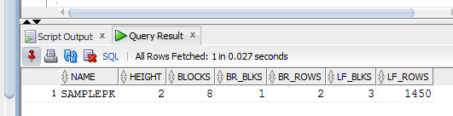
- How many levels are in the tree?
Answer: 2
- How many blocks are in the index?
Answer: 8
- How many of those blocks are branch blocks?
Answer: 1
- How many of those blocks are leaf blocks?
Answer: 3
- How many branch rows are there?
Answer: 2
- How many leaf rows are there?
Answer: 1450

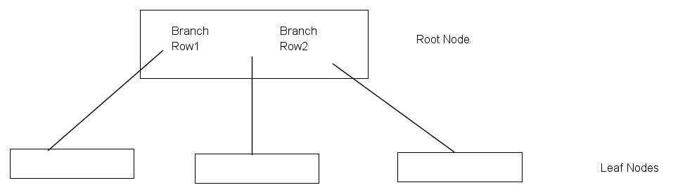

Because of a balanced tree, so each leaf node contains about 484 rows. (1450/3)

--15
a. The statement you use to determine the balance ratio.
SELECT ROUND(Del_LF_Rows_len/LF_Rows_Len * 100) BalanceRatio
FROM Index_Stats
WHERE NAME = 'SAMPLEPK';

b. What the balance ratio is.
Balance ratio: 46%

c. Does it need to be rebuilt based on your calculated value?
We need to rebuild the index because the ratio is higher than 20%

